THE EFFECTS OF THE USE OF BLOGS ON THE LEARNING PROCESS
Boyka Gradinarova ¹, Teodora Bakardjieva²,
¹Teodora Bakardjieva is Director of· Institute of Technology at Varna Free University, гр. Варна 9007, к.к. Чайка, Bulgaria, E-mail: bakardjieva@vfu.bg.
²Boyka Gradinarova is with the Department of Computer Sciences and Technology at Technical University of Varna,1 Studentska Str.Varna 9000, Bulgaria. E-mail Bgradinarova@tu-varna.bg

Abstract – Semantic blogging is a recently emerging technology that attempts to solve the problems of traditional blogging by integrating the features of the semantic web. However, the semantic capabilities currently implemented for semantic blogging are still limited. It is difficult to obtain blog entries relevant to a topic in an aggregated and organized form. A new framework for semantic blogging has been developed capable of organizing results relevant to user requirement. At the centre of this approach are the challenges of personalization and collaboration. Rather than integrating different tools into a centralized system, the idea is to provide the learner with tools and hand over control to him/her to select and use the tools the way the learner deems fit.

Keywords – blogging, semantic relations, personalization, collaboration.

- Introduction to Blogs
Blog posts or blogs are primarily textual and can vary widely in their content. They can be devoted to politics, news and sharing opinions or dedicated to technical developments. Blog entries are usually maintained in chronological order, but are usually displayed in reverse chronological order. Nardi et al. (2004) identified five reasons why blogs are used:
- to update others on activities and whereabouts;
- to express opinions to influence others;
- to seek others’ opinions and feedback;
- to “think by writing”;
- to release emotional tension.
The learning specialists Fernette and Brock Eide cited by Will Richardson (2006) identified the Potential benefits of using blogs in educational process as following:
- Can promote critical and analytical thinking.
- Can promote creative, intuitive and associational thinking (creative and associational thinking in relation to blogs being used as brainstorming tool and also as a resource for interlinking, commenting on interlinked ideas).
- Can promote analogical thinking.
- Potential for increased access and exposure to quality information.
- Combination of solitary and social interaction.
Blogging is increasingly finding a home in education (both in school and university), as not only does the software remove the technical barriers to writing and publishing online - but the 'journal' format encourages students to keep a record of their thinking over time. Blogs also of course facilitate critical feedback, by letting readers add comments - which could be from teachers, peers or a wider audience.
Students use of blogs are far ranging. A single authored blog can be used to provide a personal space online, to pose questions, publish work in progress, and link to and comment on other web sources. However a blog needn't be limited to a single author - it can mix different kinds of voices, including fellow students, teachers and mentors, or subject specialists. Edu-blogging pioneer Will Richardson (author of the main books devoted to Blogs, Wikis and Podcasts) in 2001 used the blog software Manila (http://manila.userland.com) to enable his english literature students to publish a readers guide (http://weblogs.hcrhs.k12.nj.us/bees) to the book The Secret Life of Bees. Richardson asked the book's author, Sue Monk Kidd, if she would participate by answering questions and commenting on what the students had written - to which she agreed. The result was a truly democratic learning space.
Richardson marked 10 years since his first blog post, a full decade of writing and sharing online. He defines the education reform: “We don’t need better, we need different” (Richardson, 2011)
Today’s students are immersed in the digital age, but can our educational system keep up? Best-selling author Will Richardson's comprehensive collection of posts from his acclaimed blog (http://weblogg-ed.com) outlines the educational reform we must achieve to stay ahead of the curve:
- Project-based learning
- Student-created media that develops critical thinking
- Extending learning beyond the classroom and school hours
- Cooperative and collaborative learning
- Student empowerment and career readiness
The necessary shift will not magically happen, but experts agree that it must happen now. This compilation will inspire educators and parents to engage in the technology their children already embrace, and to take an active role in transforming education to meet the challenges of the digital revolution..
- Observations and Discussions
Herring et al. (2004) defined three types of blogs: personal journals, “filters” (because they select and provide commentary on information from other websites) and “knowledge logs”. The majority of blogs are the online diary type. Bloggers are interested in reading new information, sharing knowledge and being connected with other users. While blog writers are more extroverted, blog readers are more consumerist.
The use of blogs and semantic blogs has recently been associated with a decentralised form of knowledge management (Cayzer, 2004, Breslin & Decker 2007). Semantic blogging is a technology that builds upon blogging and enriches blog items with metadata. For publishing information such as research publications, there is need of some structure and semantic blogging provides this. Items may be classified using ontologies. Semantic links may exist between items (Cayzer, 2004b). Semantic blogging uses desirable features of both blogging and the semantic web to deal with the challenges of traditional blogging. The semantic web is well suited for incrementally publishing structured and semantically rich information. On the other hand, the easy publishing nature of blogging can boost the semantic web by publishing enough data and resources (Cayzer 2004a; Cayzer, 2004b).
Semantic blogging can help users discover items of interest in blogs. Navigation through the blogosphere can be more flexible and meaningful due to interconnections among various items and topics. Aggregation of useful materials across multiple blogs and the semantic web is possible. Semantic blogging can extend blogging from simple diary browsing to informal knowledge management (Cayzer, 2004b). Publication is easy in semantic blogs too because only some additional metadata data have to be added compared to traditional blogs. The users do not need to put any effort to enjoy the additional features provided. Hence, there is not much effort added in using a semantic blog instead of a conventional one. The rich metadata and semantic structure work behind to give the user the added value experience of semantic blogging. However, the semantic capabilities currently implemented for semantic blogging are still limited. It is difficult to obtain blog entries relevant to a topic in an aggregated and organized form.
There is newly developed framework for semantic blogging capable of organizing results relevant to user requirement (Shakya, 2006). Attempts for implementation of that framework are made at Varna Free University (VFU) to provide more effective navigation and search by exploring semantic relations in blogs.
The system is built upon a blogging infrastructure backed up by an RDF metadata store. The metadata schema enriches the blog entries input. The metadata schema also helps the query processor to search by metadata. Users input queries to the system according to their information requirement. The query processor searches for matching blog entries and instances in the ontology of the domain of application. Integrated with the ontology is the inference engine, which can deduce implicit relations from the ontology. All the blog entries related to the relevant ontology instances are obtained from the blogontology mapping. The total relevant blog entries obtained are finally organized into an aggregated and navigable collection by the organizer. The system also produces output in RSS format which computers can understand and aggregate.

User query

Blog entries
Metadata
Schema

Ontology
Inference Engine
Blog
Ontology
Mapping
Blogging
Infrastructure
RDF
Metadata
Store
Query Processor
RSS Output
Search results
Organizer
Organized results

Fig. 1. System architecture of the semantic blogging framework

Some edu-blogs that are used at Varna Free University (Fig. 2, Fig. 3, Fig. 4):

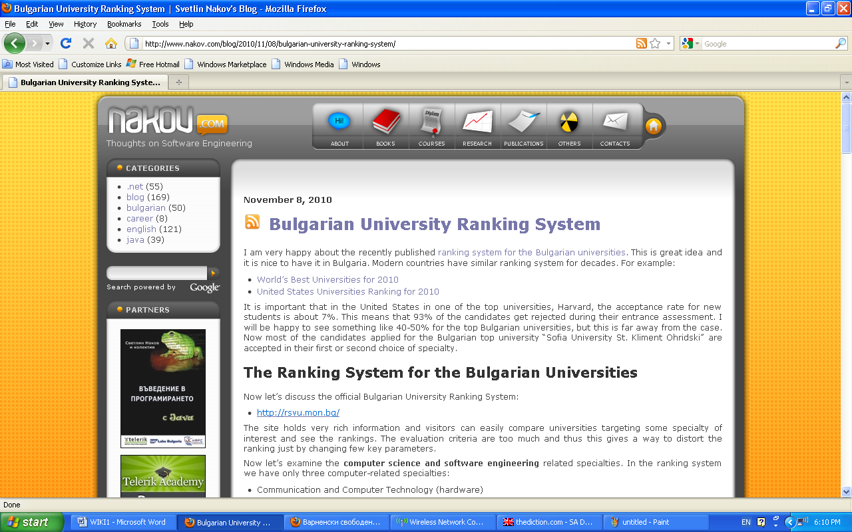

Fig. 2. Edu-blog for the Ranking System for the Bulgarian Universities
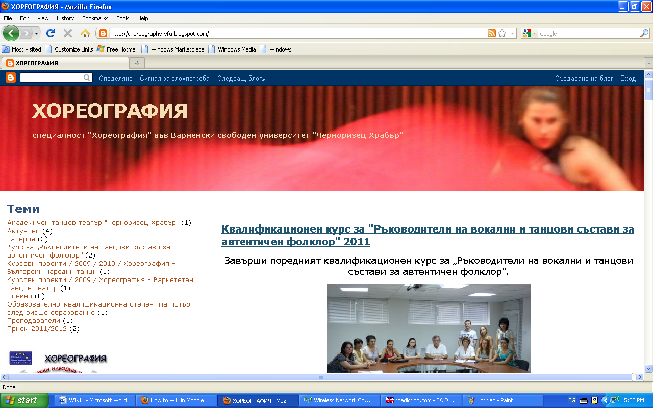

Fig. 3. Edu-blog for Choreography



Fig. 4. Edu-blog for Spatial Design

- Conclusion to Blogs
Teachers are using blogs to provide up-to-date information and commentary on their subject areas, as well as posting questions and assignments and linking to relevant news stories and websites.
They are preferred tools because they have advantage to provide reliable and safe information protected from spam.
Ontology has been introduced to utilize semantic relations, enhanced by inference. Blog entries are mapped to the ontology using language processing. Search results are organized by introducing semantic aggregation. Blog entries are enriched by metadata and an annotation mechanism has also been developed. The framework has been tested and evaluated by implementing a system for the Institute of Technology domain ontology at VFU. Experiments have shown quite good results. Single sample ontology is created for demonstration.
References
- Bates, T. (2011), E-Learning Outlook for 2011 http://www.tonybates.ca/2011/01/16/e-learning-outlook-for-2011/
- Bates, Tony (2010), Blackboard acquires Elluminate and Wimba: the end of LMSs? http://www.tonybates.ca/2010/07/11/blackboard-acquires-elluminate-and-wimba-the-end-of-lmss/
- Boulos, M. N. K., Maramba, I. & Wheeler, S. (2006) Wikis, blogs and podcasts: A new generation of web-based tools for virtual collaborative clinical practice and education, BMC Medical Education, 6(41). http://www.biomedcentral.com/ content/pdf/1472-6920-6-41.pdf (Last visited January 2011)
- Breslin, J.G, S. Decker (2007), "The Future of Social Networks on the Internet: The Need for Semantics", IEEE Internet Computing, vol. 11, no. 6, pp. 86-90pp.
- Cayzer, S. (2004a). Semantic blogging and decentralized knowledge management. Communications of the ACM, 47(12): 47-52. http://portal.acm.org/ citation.cfm?id=1035164&coll=GUIDE&dl=ACM&CFID=49 229987&CFTOKEN=13649580&ret=1#Fulltext
- Cayzer, S. (2004b). Semantic Blogging: Spreading the Semantic Web Meme. http://citeseer.ist.psu.edu/698724.html Last visited July 2011
- Chao, J. (2007) Student project collaboration using Wikis. Proceedings of the 20th Conference on Software Engineering Education and Training (CSEE&T2007), Dublin, Ireland: July 3-5.
- Chatti, M.A., Jarke, M. and Frosch-Wilke, D., (2007). The Future of e-Learning: a Shift to Knowledge Networking and Social Software, International Journal of Knowledge and Learning, IJKL, 3 (4), p. 404-420
- Chatti, M.A., Srirama, S., Kensche, D. & Cao, Y. (2006). Mobile web services for collaborative learning, Proceedings of the 4th International Workshop on Wireless, Mobile and Ubiquitous Technologies in Education (WMUTE 2006), 16–17 November, Athens, Greece.
- Godwin-Jones, R. (2003). Blogs and Wikis: Environments for Online Collaboration. Language Learning and Technology 7(2): 12-16. http://llt.msu.edu/vol7num2/ pdf/emerging.pdf Last visited July 2011 Stephen Downes, E-Learning 2.0:Notes from Stephen Downes http://www.downes.ca/ http://www.speedofcreativity.org/ 2006/10/08/elearning-20-notes-from-stephen-downes/
- Gradinarova. B. (2009). Importance of web 2.0- mediated competence for the educational demands on learners. In Proceedings of the 10th International Conference on Computer Systems and Technologies and Workshop for PhD Students in Computing on International Conference on Computer Systems and Technologies (CompSysTech '09),
- Kakizawa, Y. (2007), “In-house use of Web 2.0: Enterprise 2.0”, NEC Technical Journal, Vol. 2 No. 2, pp. 46-9.\
- Kirkpatrick, M. (2006) The flu wiki: A serious application of new web tools. http://marshallk.blogspot.com/2005/07/flu-wiki-serious-application-of-new.html (Last visited March 2011)
- Lamb, B. (2004) Wide open spaces: Wikis, ready or not. EDUCAUSE
Review,39(5) (September/October), 36-48. http://www.educause.edu/ pub/erferm04/erm O452. asp?bhcp=l
- McAfee, A.P. (2006), “Enterprise 2.0: the dawn of emergent collaboration”, MIT Sloan Management Review, Vol. 47 No. 3, pp. 1-28.
- McAfee, A.P. (2006), “Enterprise 2.0: the dawn of emergent collaboration”, MIT Sloan Management Review, Vol. 47 No. 3, pp. 1-28.
- McFedries, P.: The Web, Take Two Technically Speaking. IEEE Spectrum, June (2006)
- Mentzas, G., Kafentzis, K. and Georgolios, P. (2007), “Knowledge services on the Semantic Web”, Communications of the ACM, Vol. 50 No. 10, pp. 53-8.
- Meyer, M. (2010) Creating an Open Web 2.0 Cloud E-Learning Experience, 2010 Educause Annual Conference http://www.educause.edu/E2010/Program/SESS124 (Last visited March 2011)
- Mott, J. (2010) Envisioning the post-LMS era: the Open Learning Network Educause Quarterly, Vol. 33, No. 1
- Nabeth, T., Angehrn, A. and Roda, C. (2002), “Towards personalized, socially aware and active knowledge management systems”, in Stanford-Smith, B., Chiozza, E. and Edin, M. (Eds), Proceedings of E-business and E-work – Challenges and Achievements in E-business and E-work, Vol. 2, IOS Press, Amsterdam, pp. 884-91.
- Olson, C. (2006) New tools for learning. http://faculty.eicc.edu/golson/tools.htm (Last visited March 2011)
- O'Reilly, T.: What Is Web 2.0. In Internet: http://www.oreillynet.com/pub/a /oreilly/tim/news/2005/09/30/what-is-web-20.html
- Oren Eyal , Max Vёolkel, John G. Breslin& Stefan Decker (2006), Semantic Wikis for Personal Knowledge Management, S. Bressan, J. KЁung, and R. Wagner (Eds.): DEXA 2006, LNCS 4080, pp. 509–518, 2006, Springer-Verlag Berlin Heidelberg http://www.johnbreslin.org/files/publications/20060919_dexa2006.pdf
- Paul, C. and Schofield, A. (2010) e-Portfolios for teacher candidates Vancouver BC: UBC Faculty of Education (retrieved from http://ctlt.ubc.ca/2009/09/22/e-portfolios-for-teacher-candidates/, December 6, 2010)

- Pettenati M.C., M. Ranieri, Informal learning theories and tools to support knowledge management in distributed CoPs, E. Tomadaki and P. Scott (Eds.): Innovative Approaches for Learning and Knowledge Sharing, EC-TEL 2006 Workshops Proceedings, ISSN 1613-0073, p. 345-355, 2006.
- Razmerita, L. (2005), “Exploiting semantics and user modeling for enhanced user support”, electronic version, Proceedings of HCI International 2005
- Rogers, E. (2011) How Web 2.0 Is Influencing E-Learning http://ezinearticles.com ?HowWeb-2.0-Is-Influencing-E-Learning&id=5968742 (Last visited March 2011)
- Shakya A.(2006), A Semantic Blogging Framework for better Utilization of Information, Thesis submitted in partial fulfillment of the requirements for thedegree of Master of Engineering http://citeseerx.ist.psu.edu/viewdoc/download?doi=10.1.1.115.7250 &rep=rep1&type=pdf (Last visited July 2011)
- Surowiecki, J. (Ed.) (2005), The Wisdom of the Crowds, Anchor Books, New York, NY
- Taylor, C. (2005). It’s a Wiki, Wiki World. Time 165(23): 40-42.
- Vanderwal, T., (2005). Explaining and Showing Broad and Narrow Folksonomies, http://www.vanderwal.net/random/entrysel.php?blog=1635 (Last visited March 2011)
- Wheeler, S, Kelly P., & Gale, K. (2005) The influence of online problem- based learning on teachers' professional practice and identity. ALT-J 2005, 3(2):125-137.
- Wiki, Matrix - Compare Them All. (2007) Retrieved April 19, 2007 from
http://www.wikimatrix.org/
- Will, Richardson, Blogs, Wikis, Podcasts and Other Powerful Web Tools for Classrooms http://weblogg-ed.com/
- Will, Richardson, Learning on the Blog http://www.corwin.com/books/Book235915 ?siteId=corwin-press&subject=C00 &q=richardson

